PICNIC-GAMES

Acknowledgement

We would firstly love to give our special gratitude to our faculty members Ms. Esha Iman and Mr. Kousar Raza for assisting us, and helping us make PICNIC-GAMES a reality, it would be impossible without their immaculate guidance.

Secondly we would like to thank the E-Project team at Aptech Head Office for giving us an opportunity to showcase our talents and implement what we’ve learnt so far to build this website.

What benefits we’ve achieved:

1. How to experiment on multiple codes to get promising and especially responsive site.
2. Problem solving using google, codepen, Sass converters, Haml converters, etc.
3. Fast thinking and creative mindset in order to create individually appealing and user interactive interface.
4. Most importantly, believing in our potential to make PICNIC-GAMES a project of the month.

Introduction

In today’s busy and active world, quality time with family, friends and relatives is often overlooked, but picnics can be helpful in making up for some of this lost time. Spending time together benefits children by providing security, love, and a sense of belonging. Taking time to talk with your children is a great way to connect with them and learn from each other. Regular communication can also give family members chances to plan other fun and engaging activities. Fun games and little competitions are great ways to keep children occupied while engaging with the family.

Hence it is thought of developing a website which will provide variety of indoor/outdoor picnic games that can be enjoyed with all.

Requirement Specification

The Web site is to be created based on the following requirements.

1) The Home Page should be created making use of Sections with a suitable logo, the header section can be added which will show images of various creative products. 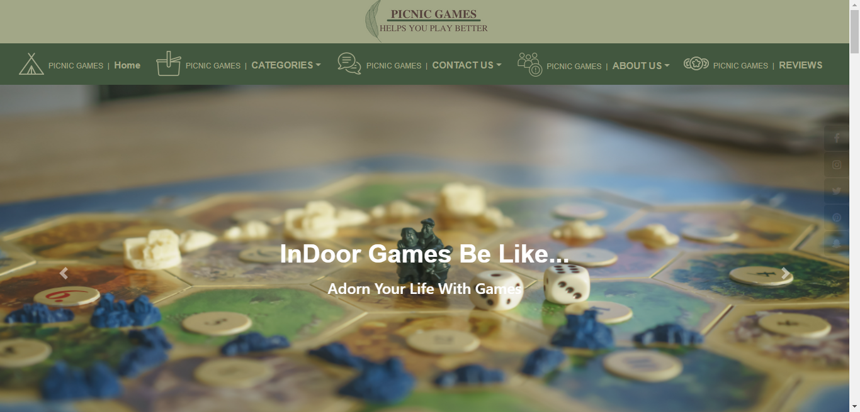2) The site must contain the links to navigate through any category for the information.

3) The games should be categorized according to the type of games indoor/outdoor.

4) Also, there should different be sections for

- Kids

- Males

- Females

- Family games

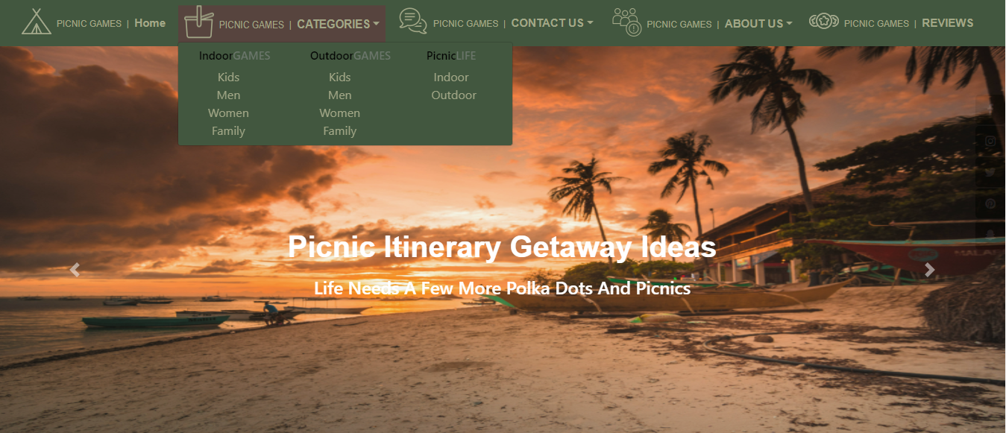

5) When a user selects any particular category, a list of available game options for that particular category will be displayed.

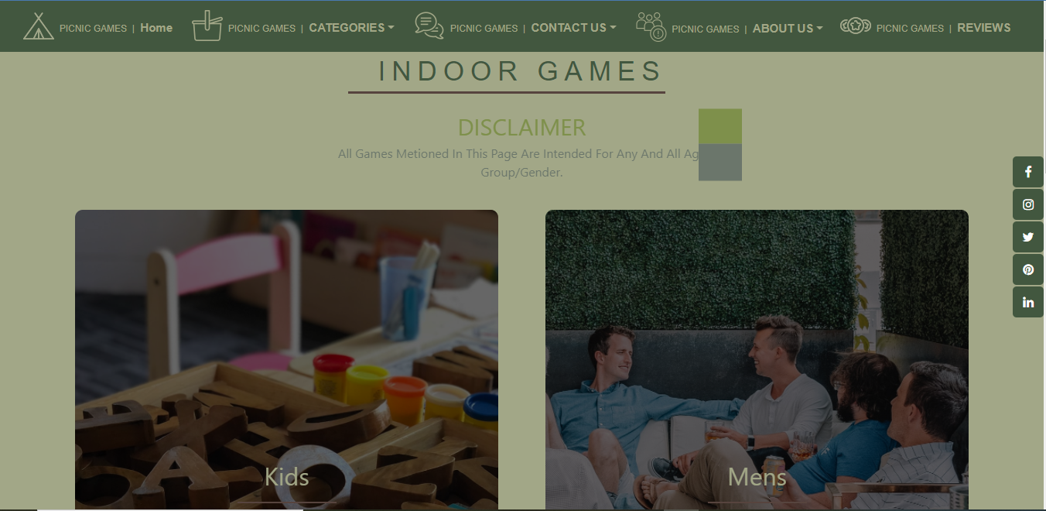

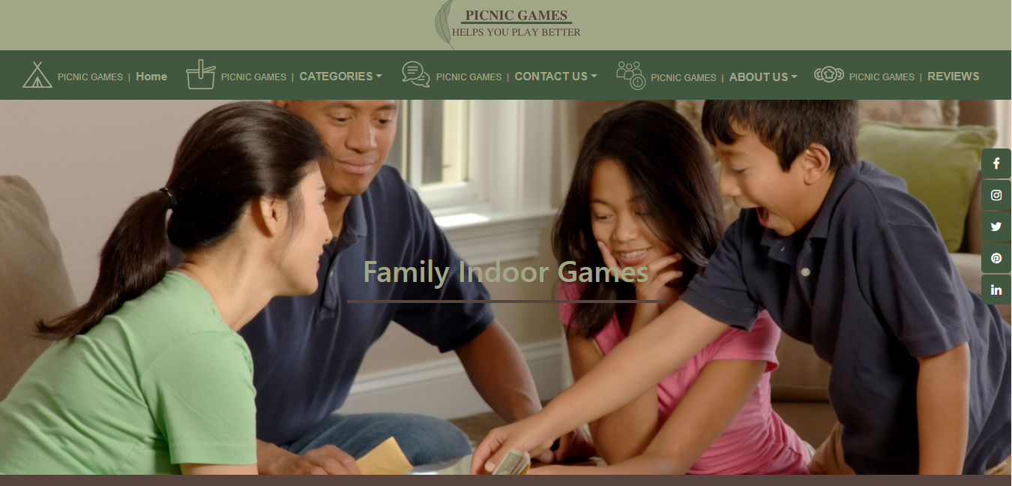

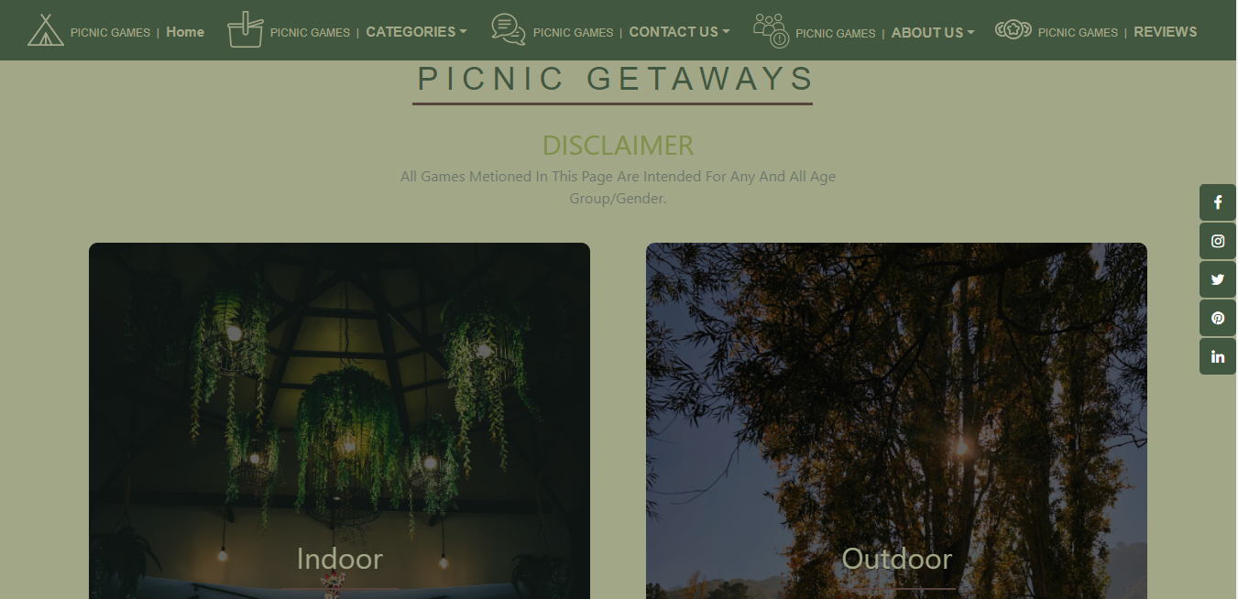

6) All details about the selected game to be displayed as material needed, time required, how to play etc. with the demo videos / instruction document, also these should be stored in Individual Word documents which can be downloaded or viewed by the User who wishes to see the same.

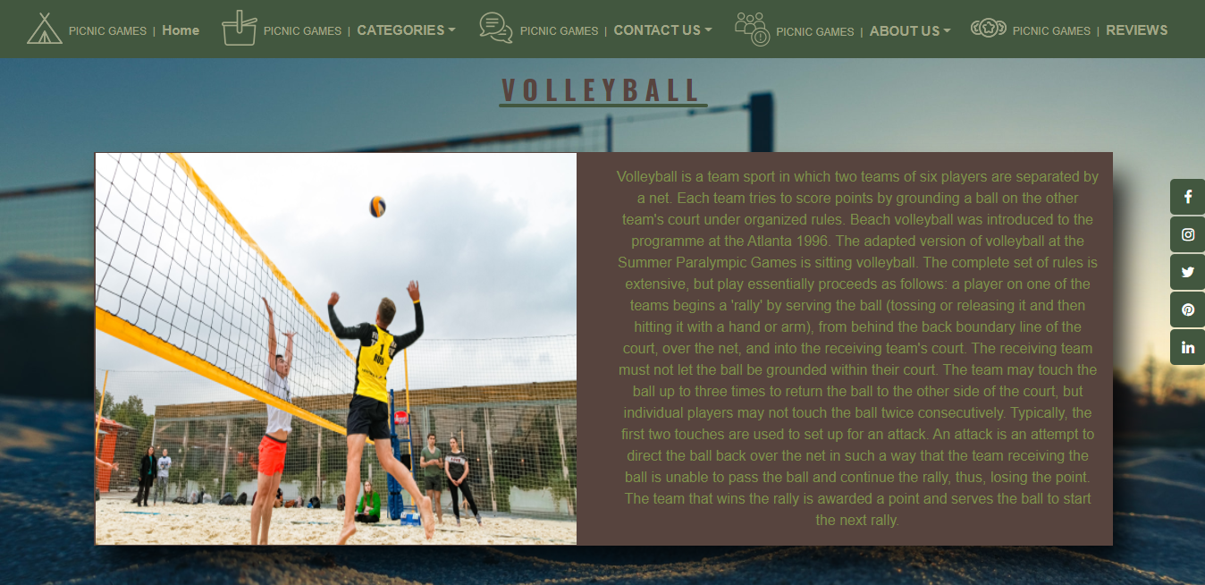

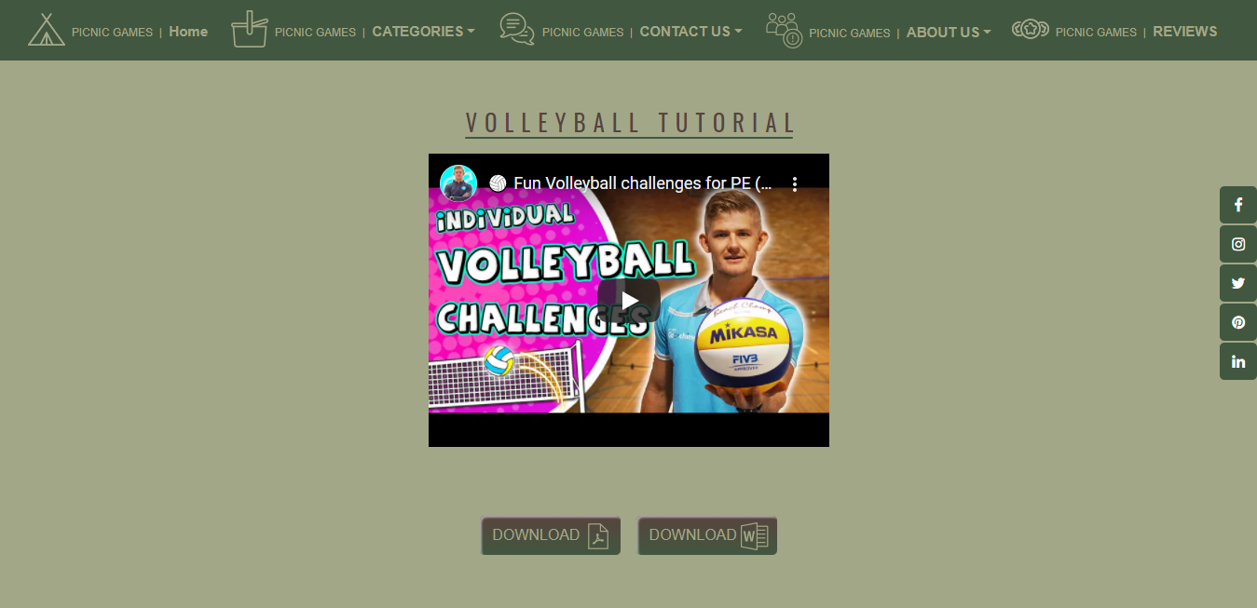

7) Along with the games there should also be a section for a common iternery for small getaways with suggested locations.

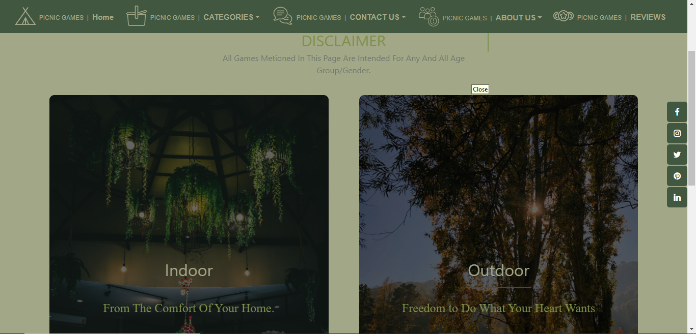

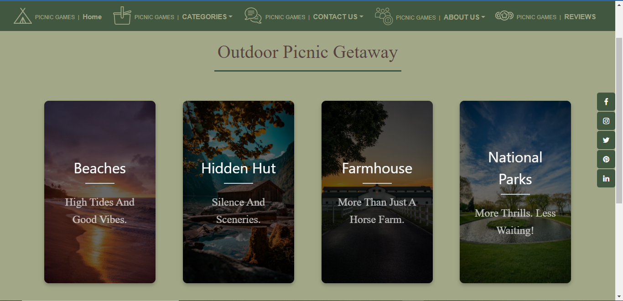

8) Site Makers Contact us page: contact us details with location should be displayed using Geolocation API (e.g., Google Maps).

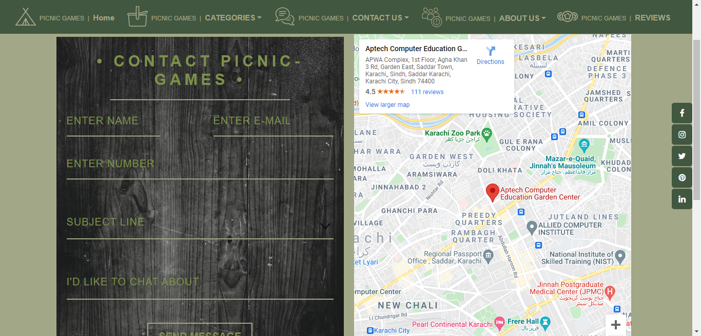

9) Responsive Site Map:

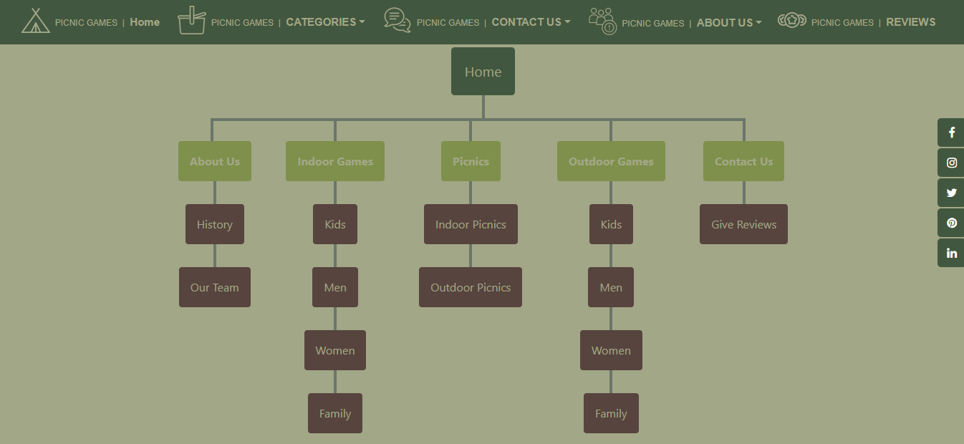

Sign-In & Sign-Up Page:

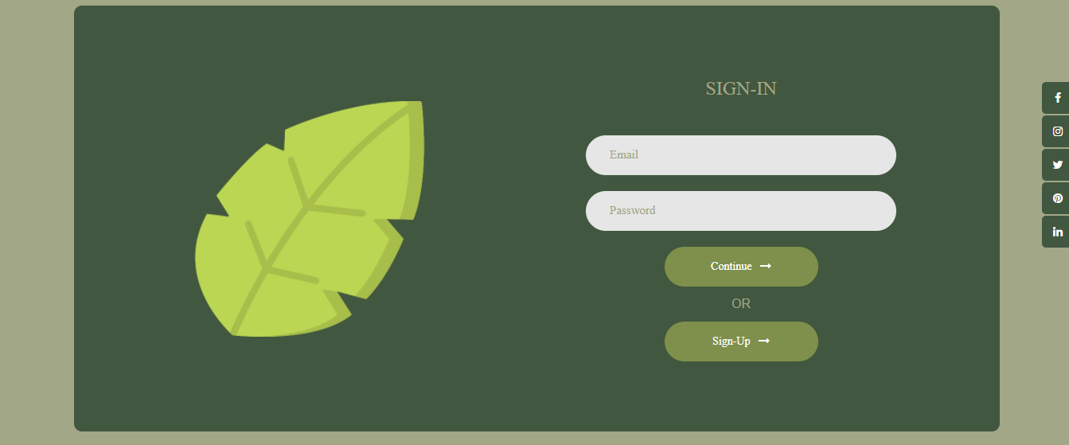

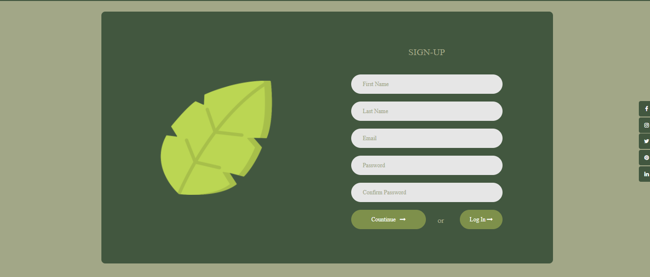

We Made Our Own Color Palette!

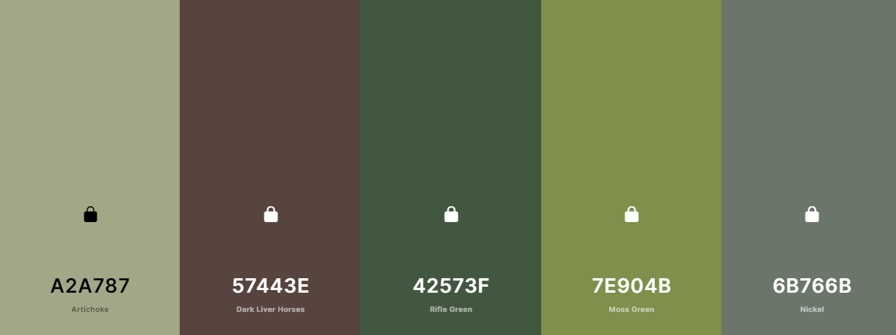

A palette that perfectly Illustrates our topic, and especially Nature! We had to add complementary colors that would work perfectly with our site.

Review Page:

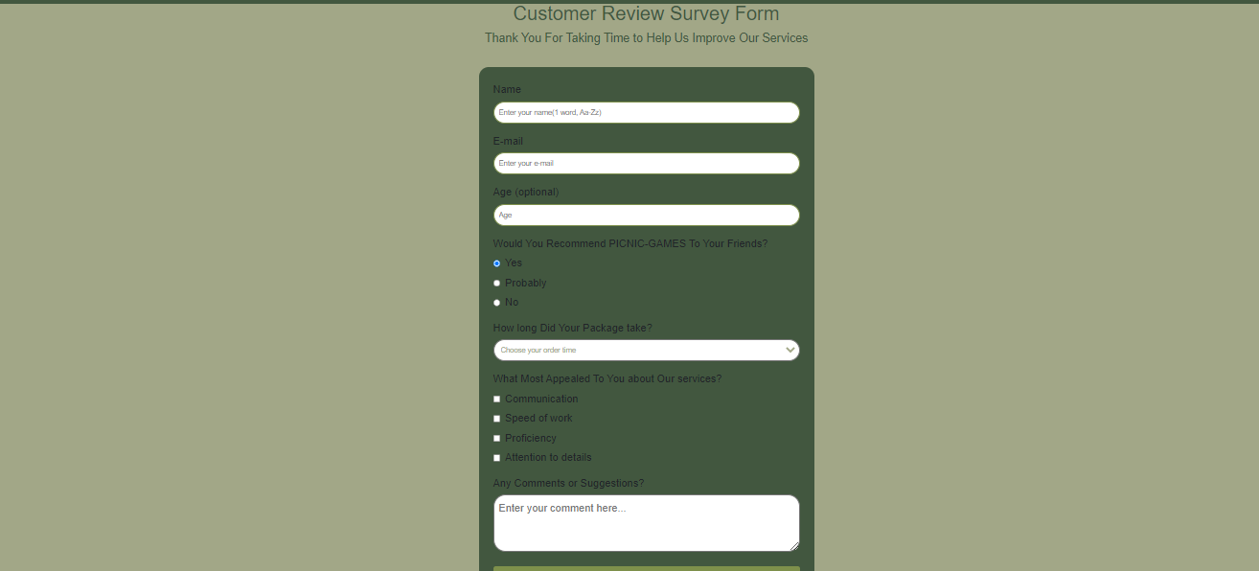

The Use of Html, Css, Bootstrap, JavaScript, and JQuery:

Html:

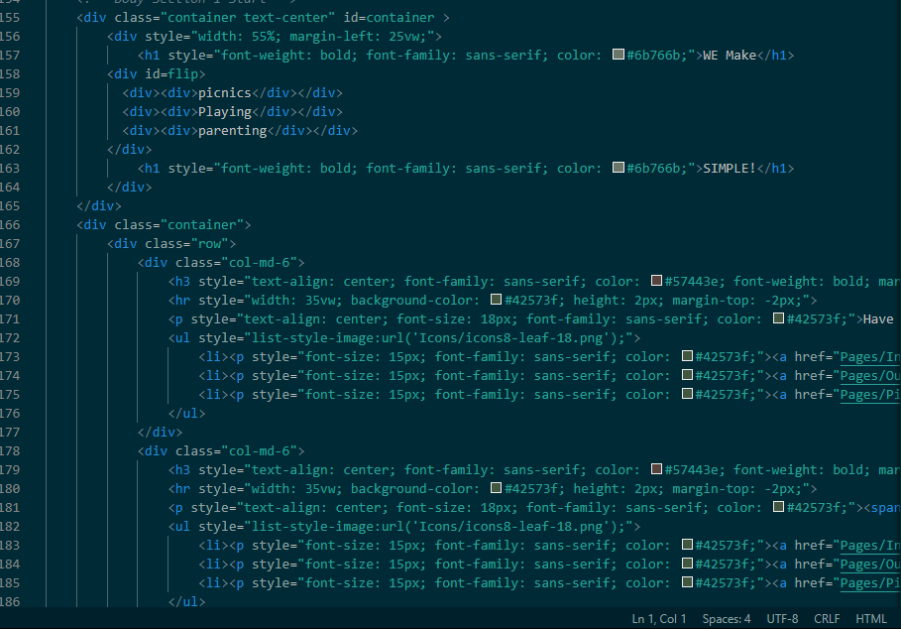

JQuery:

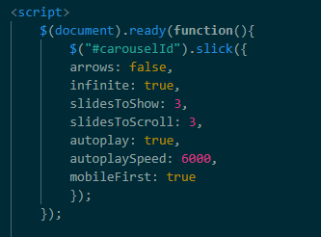

Css:

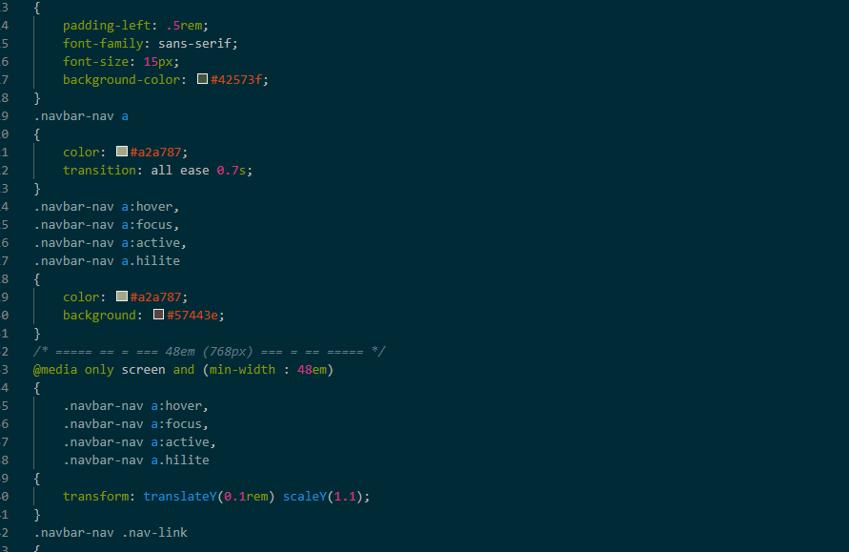Bootstrap:

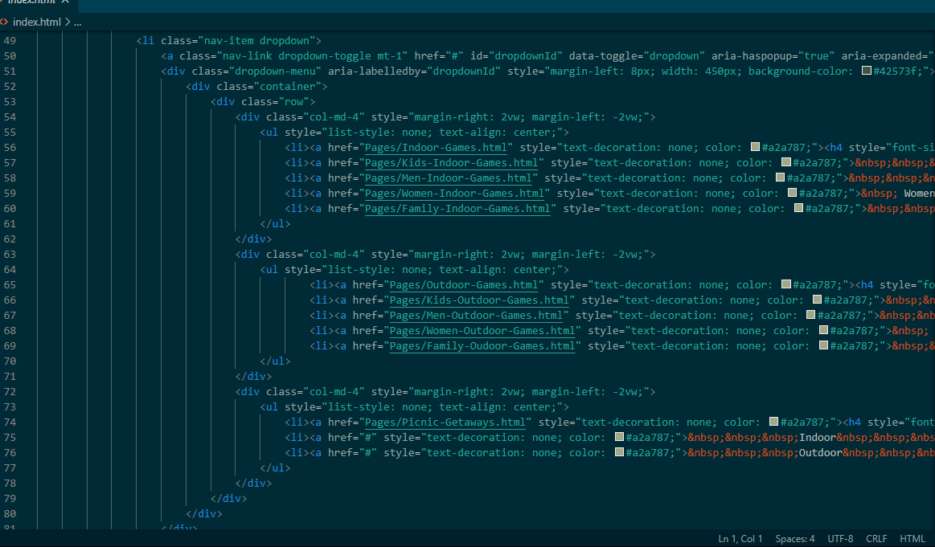

JavaScript:

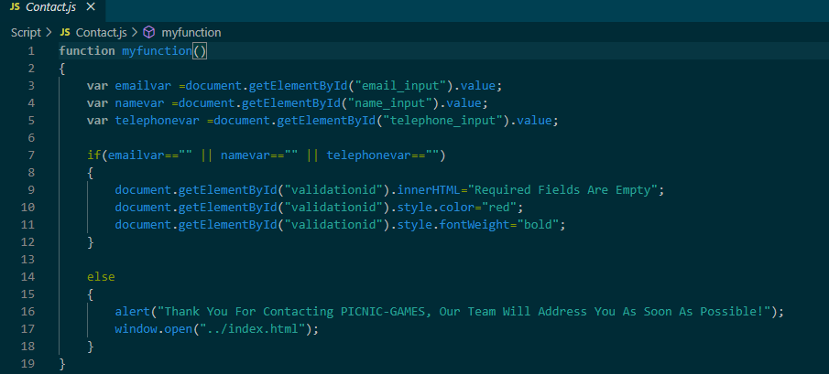

We’ve Used These Languages not only once, but multiple times throughout our site. These are just some examples.

Our Ups and Downs

**How PICNIC-GAMES Started.**  
  
In These 4 Weeks We Had Several Ups And Downs, As It Was Our First Web Designing Project And Had Numerous Breakdowns In Order To Get Each Of The Individual Page Formats In Order. Yet After Racking Our Brains For What Felt Like Weeks (About 3-4 Days) We Came Up With Our First Page Format, Which Got Our Hopes A Little Up. Right After We Figured Our 1st Format, We Completed Making Our Home Page, Which Took Us Back On Track... Or So We Thought, Our Team Soon Found Out That 1 Of The Other Grouped Had Already Built 75% Of Their Website. Whilst We Were Still 1 Week Behind Our Target.  
  
**What Difficulties PICNIC-GAMES Faced.**  
  
Don't Get Me Started At The Difficulties We Faced, From Our Website Not Being Responsive To Our 4 Pages Being Deleted!... Yes 4 PAGES Simply Deleted! WHOOOSH! But At The Time We Had No Idea That This Mistake Would Become A Bounty Instead Of Bane. We Finally Got Our 2nd Page Format. We Still Had A Long Way To Go, Yet We Were Somehow Able To Cover The Lost Time. (We Did Nothing in the Second Week From Lack Of Ideas) Our Main Focus on This Sites Concept Was To Have One Unique Animative Property, For Us Parallax Became That One USP Of Our Site (Chuckles Softly.) No Trust me, I Only Know This Much of Business Terms.

**What Has PICNIC-GAMES Become For Us.**

We initially wanted to just test our abilities in making a responsive website, but when we saw other groups giving their hundred percent, and creating their websites faster than us, we knew we had to step it up. And we didn't just want to upgrade we wanted this site to showcase all of our abilities, may it be Html, Css, Bootstrap, JavaScript, or even JQuery which we are currently still learning. We wanted this site to be created with all of the languages we have learnt in this first semester. When we saw the final product, we were amazed by the results and the efforts we put in. We just hope they were enough to make this project a memorable and a unique E-Project showcased to other Batches yet to come.

|  |  |  |
| --- | --- | --- |
| Supervisor: | SIR KOUSAR RAZA  MISS ESHA IMAN | |
| Batch: | 2109D | |
| Group: | PICNIC GAMES | |
| Serial No: | Enrollment No: | Student Name: |
| 1. | 1335121 | HUSSAIN KHOZEMA |
| 2. | 1335184 | KABEER AHMED |

THANK YOU FOR READING THE DOCUMENTATION!

WE HOPE YOU LIKED OUR PROJECT.